
Common Security Module
Test Plan

Version No: 0.1
Last Modified: 06/23/06

Author : Steve Hunter
Team : Common Security Module (CSM)
Purchase Order# 34552
Client : Nation Cancer Institute - Center for Bioinformatics,
National Institutes of Health,
US Department of Health and Human Services

Document History
Document Location
The most current version of this document is located in CVS under security/docs.

Revision History
Version Number | Revision Date | Author | Summary of Changes
0.1 | 06/23/06 | Steve Hunter | Initial Structure of Document

Review
Name | Team/Role | Version | Date Reviewed | Reviewer Comments

Related Documents
More information can be found in the following related CSM documents:

Document Name

Table of Contents
1. Introduction 4
2. References 4
3. Scope 4
4. Approach 4
5. Features to be Tested 5
6. Features not to be Tested 7
7. Testing Environment / Resources 7
7.1 Testing Environment 7
7.2 Resources 8
8. Test Deliverables 8
9. Test Schedule 8
10. Risk Issues 8
11. Roles and Responsibilities 9
12. Glossary of Terms 9

Test Plan

Introduction
This plan defines the approach, objectives, and procedures Ekagra will use to test the Common Security Module (CSM) in the coming 3.2 release. The plan’s goal is to ensure the team thoroughly tests the system so that it meets functional and technical requirements, and accomplishes the project’s mission.

To improve efficiency and avoid duplication of effort, the Test Plan will reference documents that contain the content for a given section.

References
This plan combines with other project documentation such as the Scope/Vision, Use Cases, SAD, Data Models, Test Cases, Traceability Matrix, etc., to form a complete development plan.

Some of the information contained in this document was derived from the following documents:
- Test Cases_CSM_v3.2.xls
- Requirement Testability_CSM_v3.2.xls
- UPT Full Regression Test_CSM_v3.2.xls
- Scope_CSM_v3.2.doc

Scope
Though all of the requirements and their corresponding tests are represented in this document, a detailed list of requirements for the 3.2 release can be found in the Scope document in CVS. This document will not cover the testing that is done during development (Unit Testing) or the testing of requirements of previous versions.

Approach
- As each unit of work is completed, it will be tested as soon as possible (within the next day or two). If time does not permit immediate testing, the test cases will be executed in iterations that are outlined in the Project Plan.
- Full Regression Tests will be done before pushing the product to the Staging or production tier. The Full Regression Test involves executing all of the test cases for v3.2, the automated regression test, and the UPT full regression test.
- Configuration of the DEV, QA, Staging, and Production test environment is controlled by NCICB and will remained fixed (see Environment section of this document). Any special environment configurations that need to be tested will be done on a local machine.
- All requirements that deal with a configuration change, like “Upgrade to MySQL 4.1.19” or “Ensure compatibility with SQL Sever” will be brush tested with UPT and tested with the auto-regression test.
- Execution of test cases will be recorded in the Test Case_CSM_v3.2 document. This document tracks everything involving test cases including: the pass/fail status, execution date, environment test case was executed, etc. . It will only keep a record of the last time the test was executed.
- CSM will be tested using NCICB’s standard operating procedures (SOP). This includes accepting a build revision label from the development team, re-building the software using the revision label, and deploying and testing the changes on the QA Server. For more details on the QA SOPs, refer to NCICB’s SOPs documents.
- Acceptance Testing

Features to be Tested

This topic is thoroughly covered by the Testability of Requirements_CSM_v3.2 spreadsheet. Below is a portion of this document.
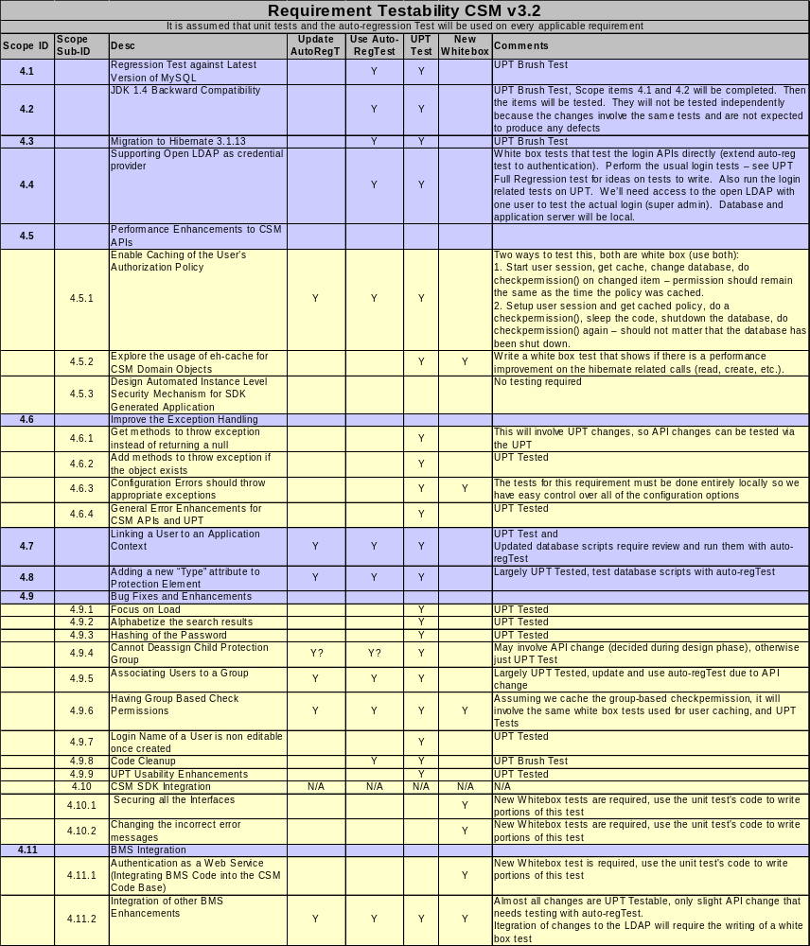

See the “Test Cases_CSM_v3.2” document for details on the test cases for each of the requirements below.

4.1 Regression Test against Latest Version of MySQL
White/Black
High level summary list of test cases

4.2 JDK 1.4 Backward Compatibility
White/Black
High level summary list of test cases

4.3 Migration to Hibernate 3.1.13
White/Black
High level summary list of test cases

4.4 Supporting Open LDAP as credential provider
White/Black
High level summary list of test cases

4.5 Performance Enhancements to CSM APIs
4.5.1 Enable Caching of the User’s Authorization Policy
White/Black
High level summary list of test cases

4.5.2 Explore the usage of eh-cache for CSM Domain Objects
White/Black
High level summary list of test cases

4.6 Improve the Exception Handling
4.6.1 Get methods to throw exception instead of returning a null
White/Black
High level summary list of test cases
4.6.2 Add methods to throw exception if the object exists
White/Black
High level summary list of test cases

4.6.3 Configuration Errors should throw appropriate exceptions
White/Black
High level summary list of test cases

4.6.4 General Error Enhancements for CSM APIs and UPT
White/Black
High level summary list of test cases

4.7 Linking a User to an Application Context
White/Black
High level summary list of test cases

4.8 Adding a new “Type” attribute to Protection Element
White/Black
High level summary list of test cases

4.9 Bug Fixes and Enhancements
4.9.1 Focus on Load
White/Black
High level summary list of test cases

4.9.2 Alphabetize the search results
White/Black
High level summary list of test cases

4.9.3 Hashing of the Password
White/Black
High level summary list of test cases

4.9.4 Cannot Deassign Child Protection Group
White/Black
High level summary list of test cases

4.9.5 Associating Users to a Group
White/Black
High level summary list of test cases

4.9.6 Having Group Based Check Permissions
White/Black
High level summary list of test cases

4.9.7 Login Name of a User is non editable once created
White/Black
High level summary list of test cases

4.9.8 Code Cleanup
White/Black
High level summary list of test cases

4.9.9 UPT Usability Enhancements
White/Black
High level summary list of test cases

4.10 CSM SDK Integration
White/Black
High level summary list of test cases

4.10.1 Securing all the Interfaces
White/Black
High level summary list of test cases

4.10.2 Changing the incorrect error messages
White/Black
High level summary list of test cases

4.11 BMS Integration
4.11.1 Authentication as a Web Service (Integrating BMS Code into the CSM Code Base)
White/Black
High level summary list of test cases

4.11.2 Integration of other BMS Enhancements
White/Black
High level summary list of test cases

4.12 Improve the Deployment of CSM & Integration with Other Applications
White/Black
High level summary list of test cases

4.13 Expose Core Authorization Services as a Web Service
White/Black
High level summary list of test cases

4.14 CSM caGrid Integration
White/Black
High level summary list of test cases

Features not to be Tested
The following CSM v3.2 requirements will not be tested because they are not a deliverable to our user base and do not require testing:
- Design Automated Instance Level Security Mechanism for SDK Generated Application
- Common Logging Module Requirement Gathering

Testing Environment / Resources

Testing Environments
- QA, Staging, and Production Servers
  - OS: Development tier - Solaris (Unix)
  - Application Server: JBoss 4.0.2
  - Database: MySQL v4.1.19
  - Java Technologies: Hibernate 3.0.5, Log4j 1.2.8
  - Web Browser: IE 5.0+, Mozilla 1.0
- Local – everything is done on one machine, so we have complete control over environment
  - OS: Windows 2000
  - Application Server: JBoss 4.0.2
  - Database: MySQL v4.1.19 AND SQL Server v?.?, Tomcat
  - Java Technologies: Hibernate 3.0.5, Log4j 1.2.8
  - Web Browser: IE 5.0+, Mozilla 1.0

Resources
The following resources will be used to conduct the testing of CSM.
- Software configurations
  - JBOSS 4.0.1
  - j2sdk1.4
  - MySQL 4.1
  - Java Virtual Machine
  - Struts Framework 1.1
  - Oracle 9i
  - Tomcat web container
- Development Software
  - Eclipse and myEclipse plug-in
- Test tools
  - JUnit
  - OpenSTA (Open System Testing Architecture) REMOVE ME?!
- Documentation
  - CSM Scope/Vision 3.1
  - Relevant design documents
  - Test Plan_CSM_v3.2 (this document)
  - Test Cases_CSM_v3.2
  - CSM Guide for Application Developers
  - SDK Programmer’s Guide
- User Interface
  - Web interface (IE Explorer, Mozilla Firefox)
- Web Server
  - Apache web server
- Operating system
  - Windows 2000,NT,XP
  - Unix (Sun Solaris)

Test Deliverables
The following QA related documents will be delivered to NCICB management for review:
- Test Plan_CSM_v3.2 – this document
- Test Cases_CSM_v3.2 – provides a detailed list of the test cases that will be done to test the new 3.2 functionality.
- Test Summary Report_CSM_v3.2 – summarizes the results of testing

Test Schedule
Other than a few requirements that will be grouped and tested simultaneously, each requirement will be tested as soon as it is completed. Since some of these requirements will be completed at varying times, detailed testing dates will not be provided. For a comprehensive schedule of milestone testing activities, refer to the Project Plan in CVS.

Below is list of the projected milestones and completion dates:

Risk Issues

Usability Risks
Risk:
End users may not be happy with the added level of complexity for our solution to returning large numbers of users.

Response to Risk:
We will check with our user base to get an opinion on the matter.

Roles and Responsibilities
The Team’s Testing Responsibilities:
Name | Job Title | Role in Testing
Charles Griffin | Project Manager | Ensure QA related deadlines are met
Kunal Modi | Team Lead | Aid in development of integration tests
Orlando Roebuck | Developer | Aid in development of integration tests
Steve Hunter | Quality Assurance | Plan, write, and execute test cases, post defects, ensure quality in deliverables

Glossary of Terms

- Unit Testing - Controlled evaluation in the development step to ensure that one component of program code performs as defined in the specification.
- Integration Testing – Controlled evaluation performed to ensure that a collection of programmed units work together to produce expected results as defined in the functional requirements.
- Systems Testing – Controlled evaluation of an application in the context of a system to ensure that the application works within the system environment.
- Load Testing – Testing with a large amount of virtual users and/or data in order to better predict system behavior and performance under extreme production conditions.
- Acceptance Testing – The process whereby end users performing final testing of an application prior to its release to production. The focus is on whether or not the application meets user requirements and produces correct results.
- White Box – Tests that are written and executed with knowledge of the code or inner workings of the software
- Black Box – Tests written and executed without knowledge of the code or inner workings of the software
- Acceptance Criteria - Any objective quality standards that the software must meet, in order to be considered ready for release. This may include things like stakeholder sign-off and consensus, requirements that the software must have been tested under certain environments, minimum defect counts at various priority and severity levels, minimum test coverage numbers, etc.

